

Law Enforcement
Liaison Office
1401 Broadway
San Diego, CA
92101-5729

San Diego
Police Officer
Mark Herring
(619) 531-1500

San Diego
Sheriff's Deputy
Marcial Lopez
(619) 531-1547

Information Wanted on Hit & Run Causing Serious Injury
Up to $1,000 Reward Offered
_________________________________________________________________________________________________________
April 15, 2021

San Diego County Crime Stoppers and investigators from the San Marcos Sheriff's Station want your help in solving a hit and run collision that seriously injured a 71-year-old man.

It happened on April 1 just before 8:00 p.m. along Woodland Parkway, just north of Fulton Drive, in San Marcos. When deputies arrived on the scene, they found 71-year-old Steven Drake lying on the ground. He had been hit by a car that left the scene.

Drake was rushed to a hospital with a traumatic brain injury and immediately placed on life support. He has since been removed from life support, but is facing a long road to recovery.

Unfortunately, there were no witnesses or video surveillance footage of the incident.

However, Sheriff's Investigators have identified a type of vehicle of interest (see above): a silver 2013-2016 Audi A4 with S4 trim line. The car may have front passenger side damage. It will also be missing its passenger side fog light bezel and passenger side headlight washer cover.

*** A photo of the vehicle of interest can be found on page 2 of this release***

Anyone with information about this incident is asked to call San Marcos Sheriff’s Traffic Division at (760) 510-5295 or the Crime Stoppers anonymous tip line at (888) 580-8477. Crime Stoppers is offering up to a $1,000 reward to anyone with information that leads to an arrest in this case. Visit www.sdcrimestoppers.org for information on how to send web or mobile app tips.

- Media inquiries about this case can be directed to Sergeant Charles Morreale at (760) 510-5295 or email at Charles.Morreale@sdsheriff.org.

- Inquiries about Crime Stoppers can be directed to Officer Mark Herring at (619) 531-1500 or msherring@pd.sandiego.gov or Deputy Marcial Lopez at (619) 531-1547 or email at marcial.lopez@sdsheriff.org .

San Diego County Crime Stoppers Media Release
April 15, 2021
Page 2

Picture of Similar Vehicle of Interest:

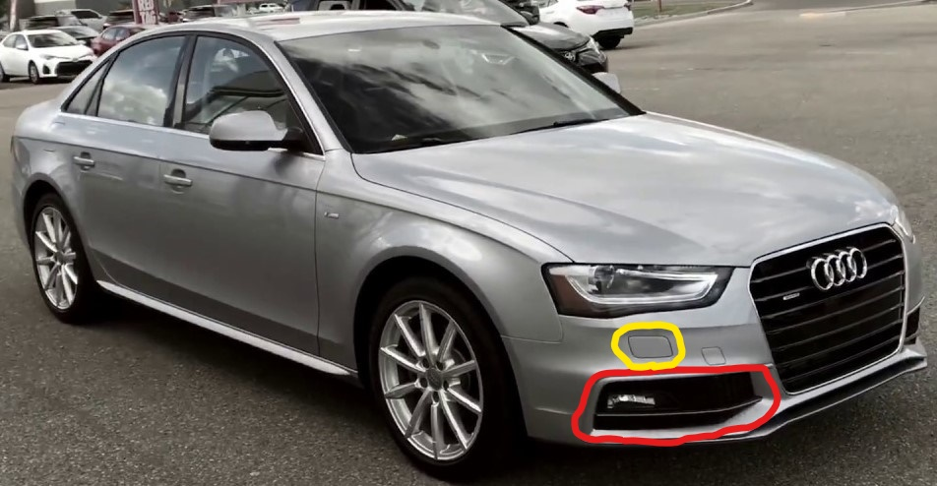
*Not Actual Vehicle*

